** KONGU ENGINEERING COLLEGE**

**(Autonomous)**

**PERUNDURAI ERODE – 638 060**

**CARNIVAL APPLICATION**

**A PROJECT REPORT**

**Submitted by**

# JANARTHANAN T

# 20ITR038

# LOGESH B

# 20ITR057

**DHANUSHYA S**

**20ITR020**

**FAHIMA BEGUM B**

**20ITR024**

**Guided by**

**Dr.R.Rajadevi**

**DEPARTMENT OF INFORMATION TECHNOLOGY**



### Table of Contents

**S.No. Title Page No.**

### 1 Introduction 3

### 2 System Implementation

2.1 System Architecture Diagram 3

2.2 Module Description 4

**3 Result**

3.1 Implementation 4

3.2 Result Analysis 5

### 4 Conclusion and Future Work

4.1 Conclusion 5

4.2 Future Work 5

1. **INTRODUCTION:**

Carnival application is designed to overcome the problem of promotion for each and every event in the college. The process of promoting an event is difficult and not all the students are aware of it. By using this application, it is easier for everyone including the coordinators and faculty to know about the happenings of the event. It is created to make the registration process easy. Overall the website is to describe an event and to register for a particular competition . The coordinators can easily collect the data of registered participants. It is designed to be colorful and provide the feel of college fests

1. **SYSTEM IMPLEMENTATION:**
   1. **SYSTEM ARCHITECTURE DIAGRAM**

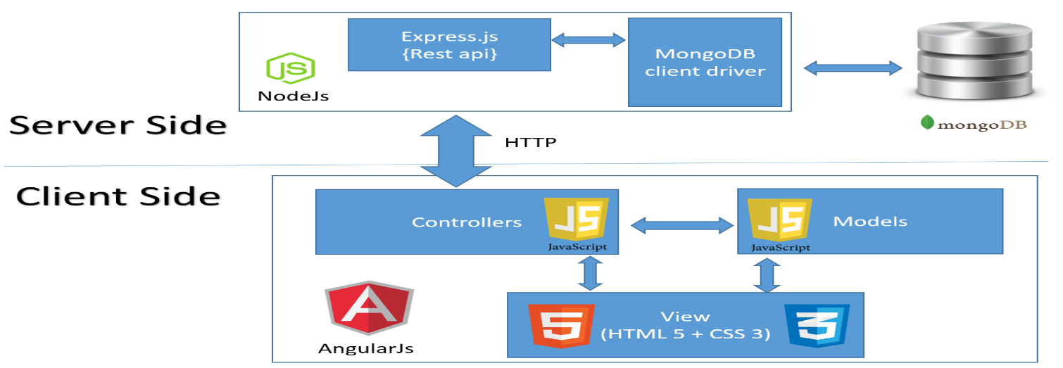

* 1. **MODULE DESCRIPTION:**

We are creating the platform for a college which have lots and lots of clubs. In our website we have created the integrative platform for all the clubs in college. From our website, all clubs have access to register and post their events. The students in the college can visit our website and check for upcoming events and also register for that event which is posted by the club members.

For each club, there is a staff and student co-ordinator who only have access to post the event under their club and check for participant who are register for that particular event which is posted. There is an admin who only have a access to create a club. While creating a club the admin wants to ensure that who are all the staff and student co-ordinator.

1. **RESULT:**
   1. **IMPLEMENTATION:**

Carnival application can be used only by registered users. It can be divided into 3 modules, students, coordinators and admin. The home page will have registered clubs of our college and the description of each club. By clicking on the view more option of each club, the page navigates to another page where the events related to each club will be displayed. If the coordinators log in to this application, they will have three buttons to delete ,create or modify the events. This option will not shown to the students. On clicking the the events, we can view it in detail and register for the events. The coordinators can see the number of students registered and also download the file as pdf or excel sheet. Only the admin can create the clubs and coordinators can create event

* 1. **RESULT ANALYSIS:**

The end users of carnival are students, coordinators and admin. The admin can create the clubs present in the college and the coordinators can create , delete or edit the events of each club. Carnival can be used for promoting an event. The students and faculty members can know about the events in detail and also register for it. All the students can know about every event through this website. In future we would like to develop this website in our college and improvise it further more so that it becomes the official website for registering to any kind of event.

1. **CONCLUSION AND FUTURE WORK:**

**Conclusion:**

Thus, this platform acts as a single integrated online platform for posting events and symposiums which allows users like Clubs and Events co-ordinators to post, edit and delete events and can also have control over list of registrants, which they can also download as pdf or excel file. The end users are admin, co-ordinators and students.

**Future Works:**

1. Implementation of this website in college level